Computer Networks

Practical File

Sem-4



Submitted to: Nikhil Rajput

Submitted by: Amar Kumar

Roll no. 20221461

BSc(Hons) Computer Science

Q1. To study basic network command and network configuration commands

Output:

1. ipconfig

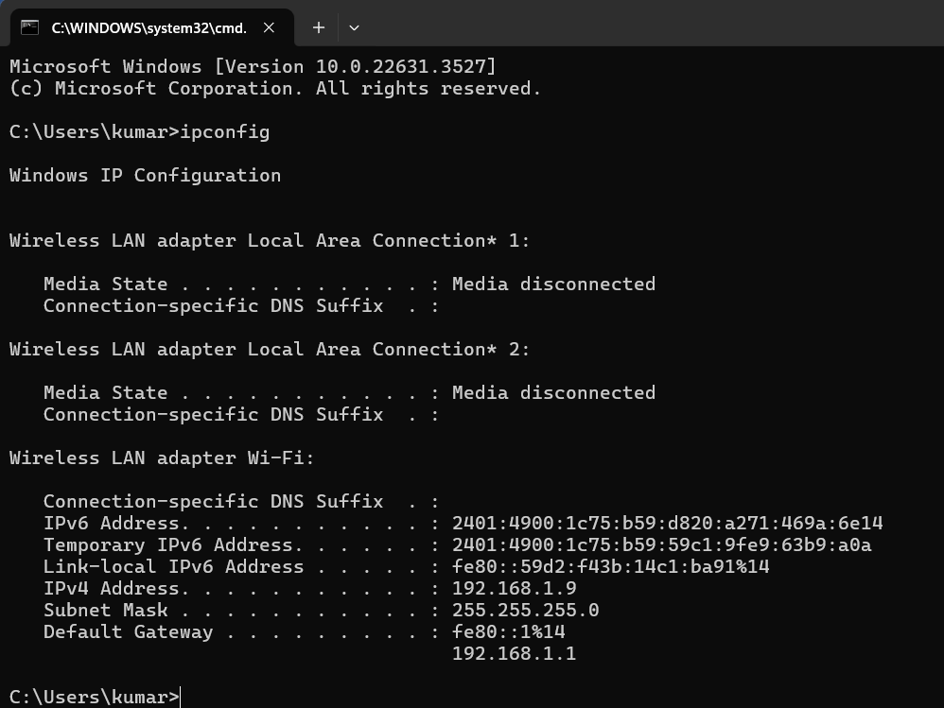

1. 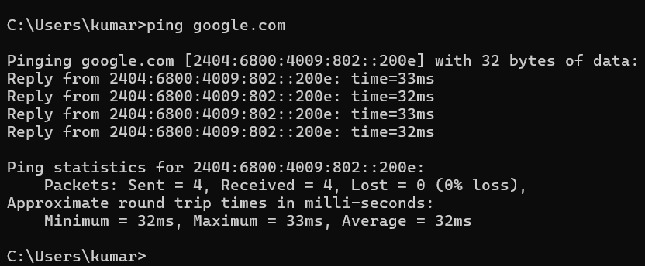ping
2. tracert

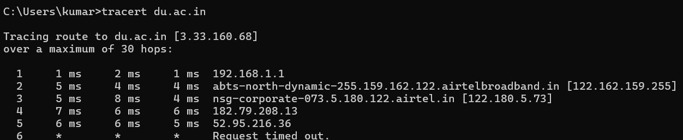

1. nslookup

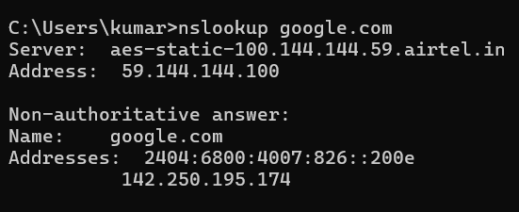

1. netstat

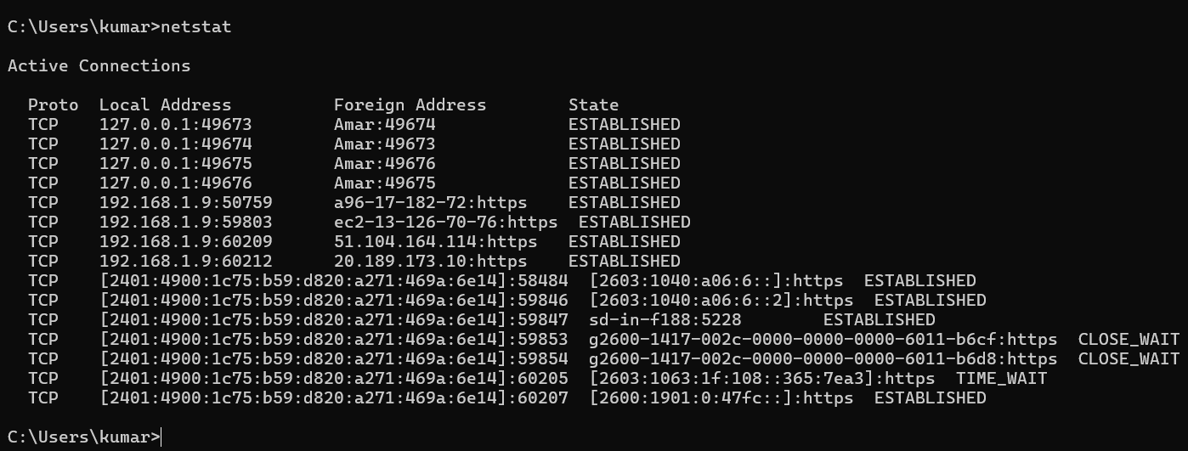

Q2. To study and perform PC to PC communication using ethernet

Steps to be followed:

1: Open Cisco Packet tracer Application

2: Create new file and add 2 PCs to the screen by dragging from bottom of screen

3: Connect the 2 PCs using cables and use any cable u like. In my case I am using crossover cable and adding fast ethernet to both.

4: To assign ip to PC click on PC🡪Desktop🡪IP Configuration and type ip address 192.168.1.1 on 1st PC and 192.168.1.2 on 2nd PC.

5: Then select add sample PDU and select the origin PC and destination PC.

6: Use simulation and see how packet is travelling.

Output:

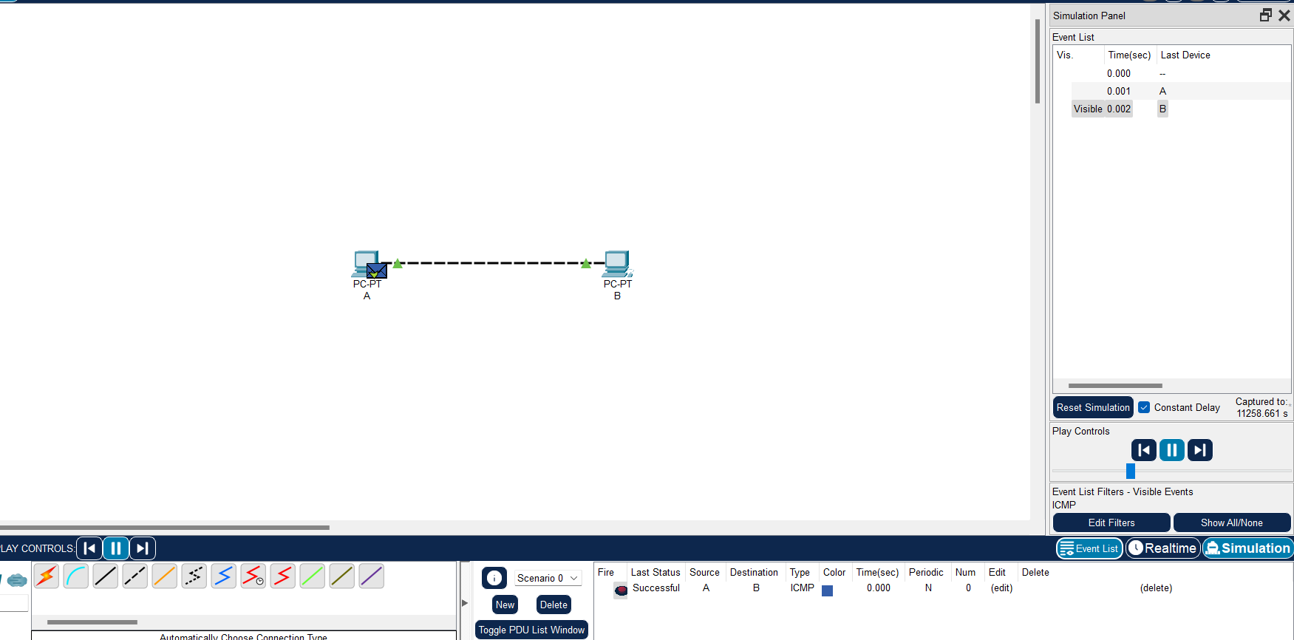

Q3. To create Star topology using hub and switch

Steps:

1. Add PCs and a switch in between on one part of screen and more PCs and hub on the other part of the screen.
2. Connect each device to hub and switch
3. Configure each ip address for all devices as shown in picture like 172.16.0.1 etc.
4. To check connection ping a PC 172.16.0.1 with 172.16.0.4, use command ping 172.16.0.4 on pc1.
5. Select add sample PDU and select origin and destination PC using simulation see how packet is transferring.

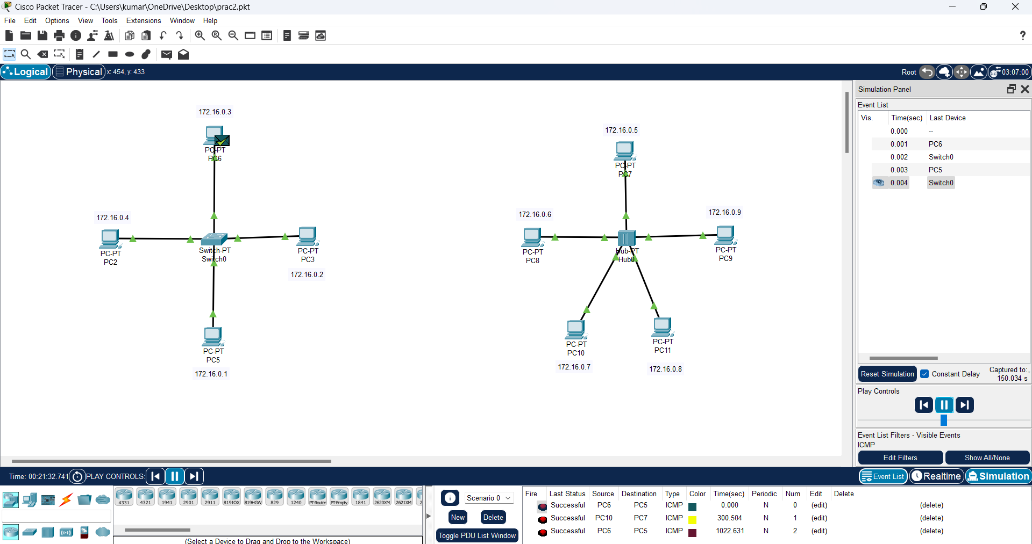Output:

Q4. To create Bus, Ring, Tree, Hybrid, Mesh topologies

Steps:

1. Add PCs and corresponding switches according to the topologies
2. Connect each device to switch according to topologies
3. Configure IP addresses for all PCs
4. Check connection using ping command
5. Add sample PDU and see simulation

Output:

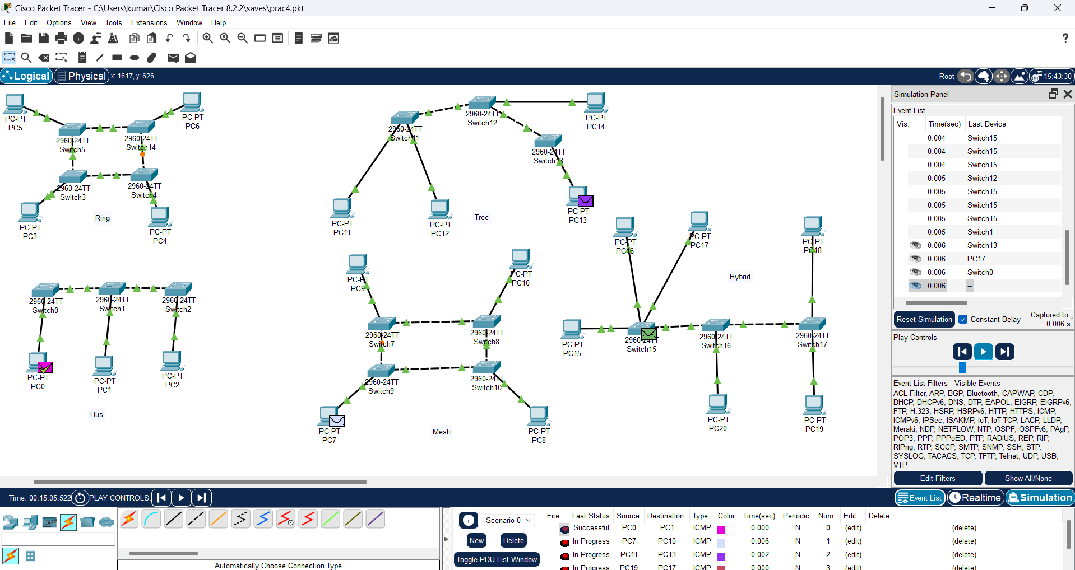

Q5. Perform an initial Switch configuration

Steps:

1. Open Cisco Packet tracer
2. Drag and drop switch from bottom left area to workspace
3. Connect a PC if u want to the switch using ethernet cables
4. Access switch CLI and enter enable command
5. Examine the current switch configuration by show running-config command.
6. Enter command configure terminal🡪hostname test
7. Verify Configuration by running: show interfaces, show vlan, show ip interface brief

Output:

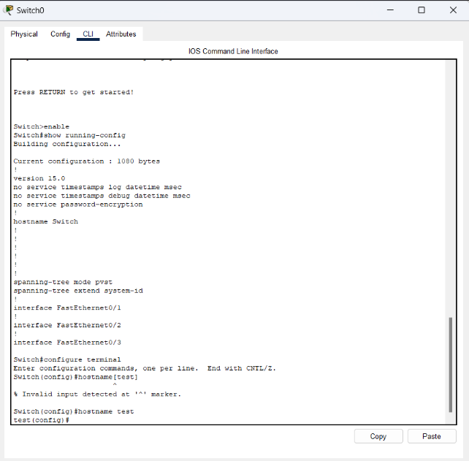

Q6. Perform an initial Router configuration

Steps:

1. Open Cisco Packet Tracer
2. Drag and drop Router
3. Connect devices
4. Access router CLI
5. Configure router using following commands: enable🡪 configure terminal🡪 hostname amar
6. Configure interfaces use command: interface🡪ip address🡪no shutdown
7. Configure default gateway: ip default-gateway 192.168.0.1
8. Verify Configuration: show interfaces🡪show ip interface brief🡪show ip route
9. Exit: exit

Output:

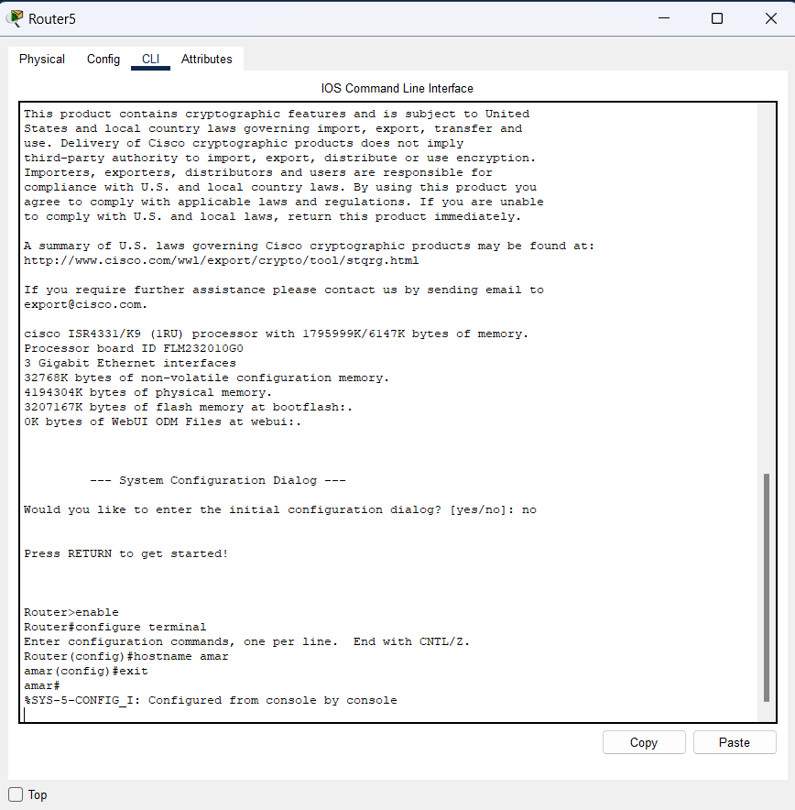

Q7. To implement Client Server Network

Steps:

1. Launch Cisco Packet Tracer and create a new empty workspace.

2. Drag and drop devices from the “End Devices” and "Routers" sections to design your network topology.

3.Connect the devices using appropriate cables (Ethernet, Serial, etc.) to establish network connectivity and add ip addresses to each.

4. Add and configure the server, make changes in server http and dns

5. Configure Client

6. Test Connectivity using ping command

Output:

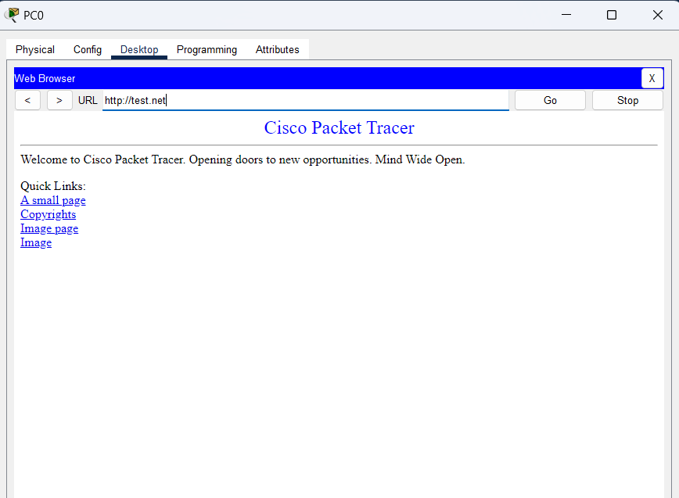

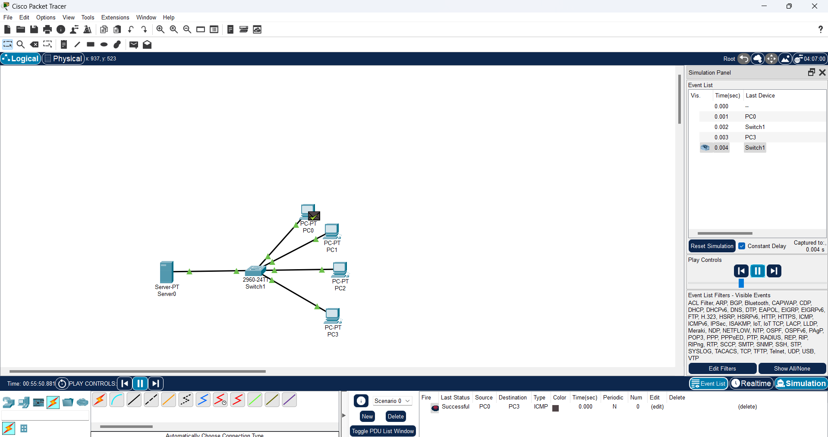

Q8. To implement connection between devices using router

Steps:

1. Design the topology using devices and cables
2. Configure Ip addresses on the devices add ip addresses on both laptops
3. Configure routing go to router 🡪config then in Gigabit Ethernet 0/0/0 turn it on and put ip address and in gigabit Ethernet 0/0/1 turn it on and put ip
4. Test Connectivity using simulation

Output:

